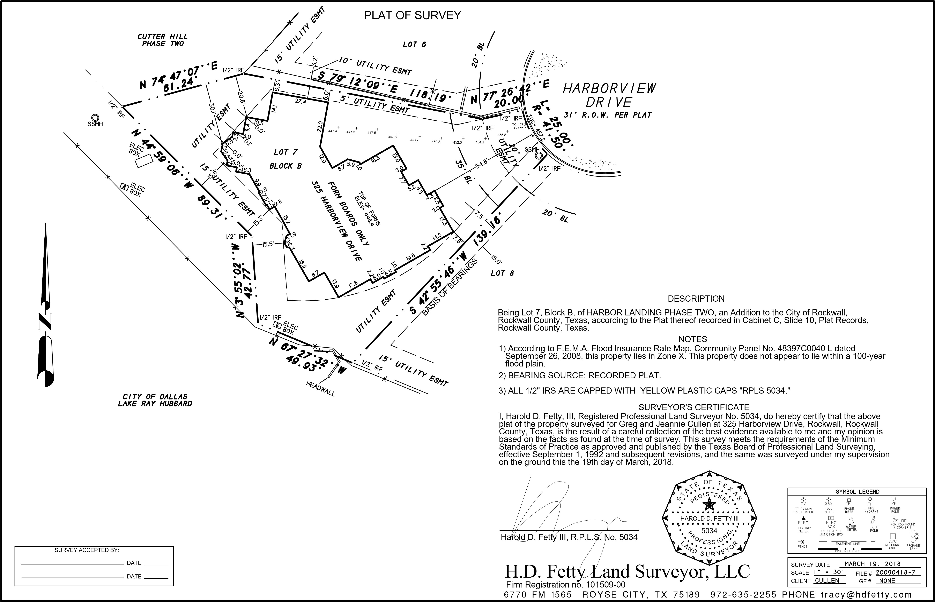

**We found 2 six inch lines in the excavation. Both blue pipe, the long one was thin wall, the short one was C900. The short one was full of mud and we could not camera it. We ran camera towards lift station on the long one and hit mud within 5 ft.**